Course: CS420 - Artificial Intelligence

02 – Adversarial Search

Question 1. Consider the game search tree shown below, in which a square denotes MAX’s move and a circle for MIN’s move.
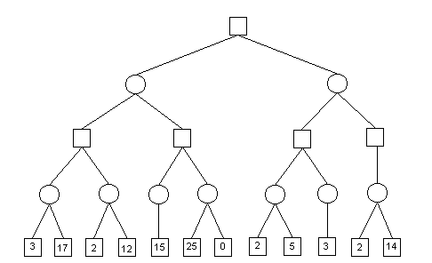
Note the minimax value for each node of the tree using Minimax algorithm without pruning.
Then, show where alpha-beta pruning occurs by crossing out corresponding branches. Briefly explain each case.

Question 2. Consider the following game tree.
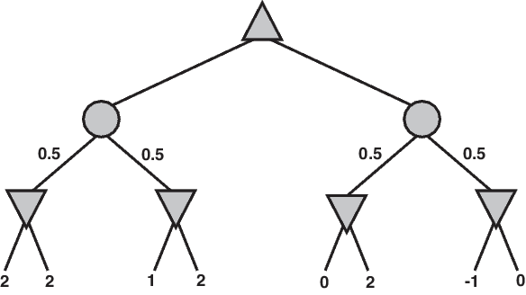
Calculate the expectimax value at every node in the tree.
Now assume that the value at each node is at most 2. Identify and mark any branches that can be pruned, and provide an explanation for each pruned branch.

Question 3. Consider the following game tree. Calculate the UCB1 values for the nodes in the tree using the formula given in the lecture) with C = 2.
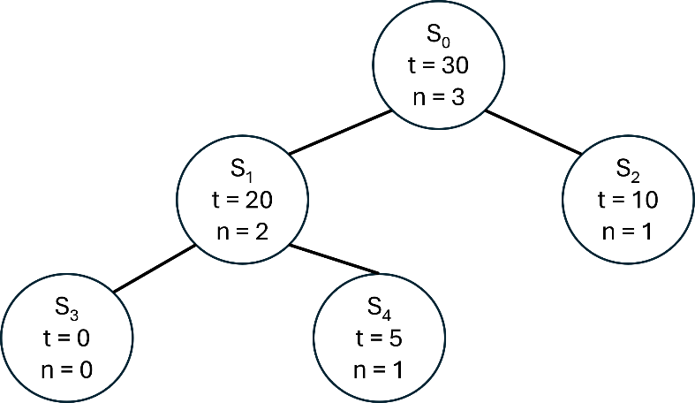
Assume that a roll-out is performed on the given tree, resulting in a value of 20. Please update the statistics for the corresponding nodes in the tree.

